Urban Retail Co. Inventory Management Analysis

Comprehensive Data-Driven Optimization Report

# Table of Contents

1. Executive Summary
2. Introduction and Methodology
3. Current Inventory Performance Analysis
4. ABC Classification Analysis
5. Seasonal Trends and Impact
6. Critical Inventory Risks and Opportunities
7. Working Capital Optimization Strategy
8. Implementation Roadmap
9. Financial Impact Projection
10. Conclusion and Recommendations
11. Appendices

# 1. Executive Summary

Urban Retail Co. operates **20 store locations** offering **30 product SKUs** across five major categories: **Clothing, Electronics, Furniture, Toys, and Groceries**.

The company maintains strong inventory management fundamentals with a **62.31x** average turnover ratio and a perfect **100% fill rate** across all locations.

Total inventory investment stands at **$9,519,914.11**, representing approximately **3.5%** of annual revenue.

[**Urban Retail Co. Executive Inventory Dashboard**](https://nwesha.github.io/Dashboard_urbanco_inventory_optimised/) 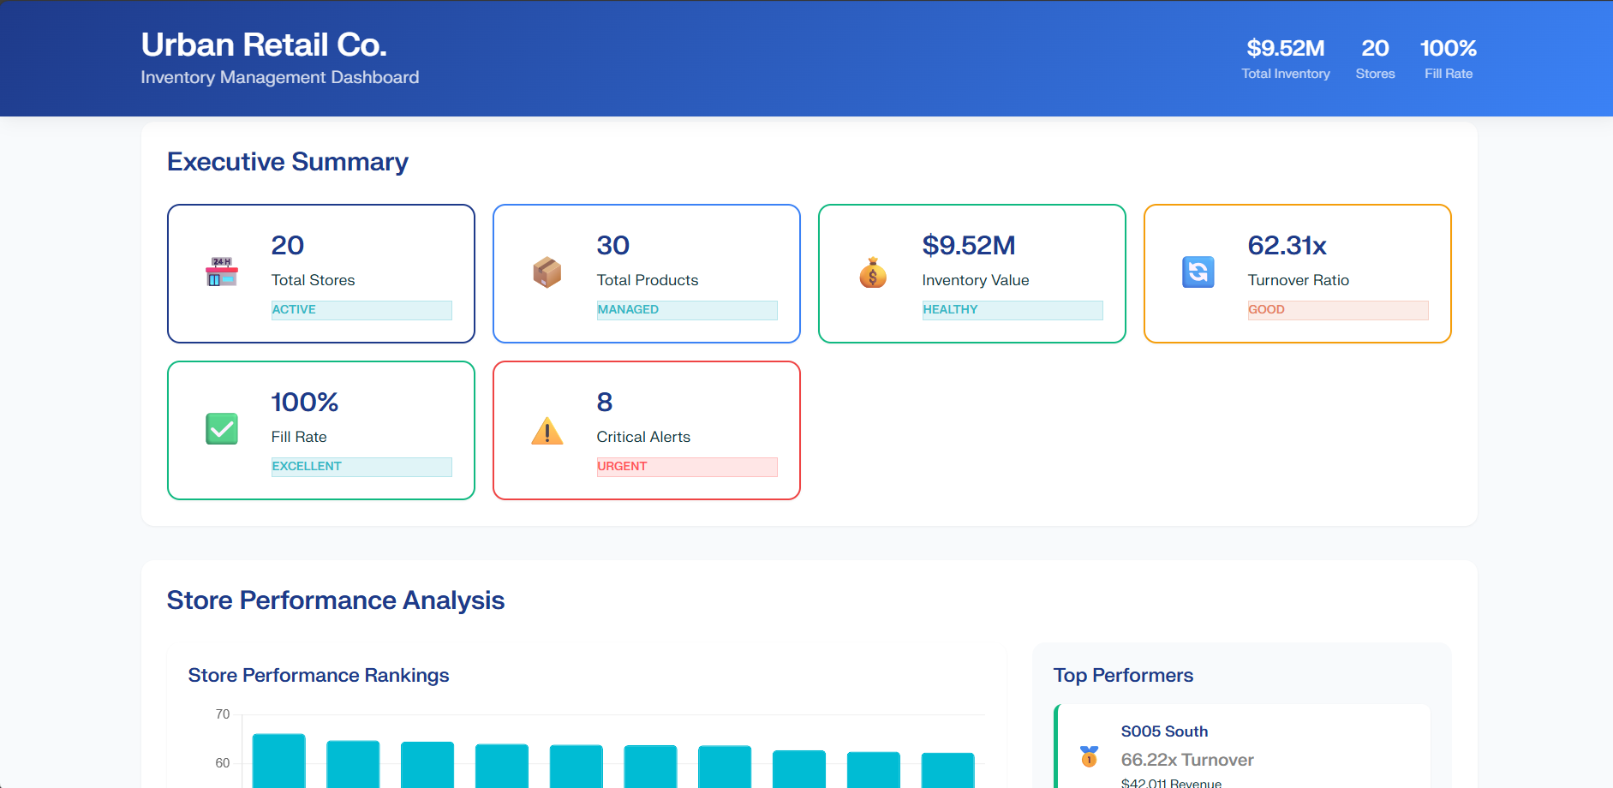

Despite these strengths, our analysis identified 11 critical reorder items requiring immediate attention to prevent stockouts, with S003 West P0016 (Clothing) having less than one day of supply remaining. Additionally, 304 underperforming SKUs present an opportunity to release approximately $511,290 in working capital through strategic inventory reductions.

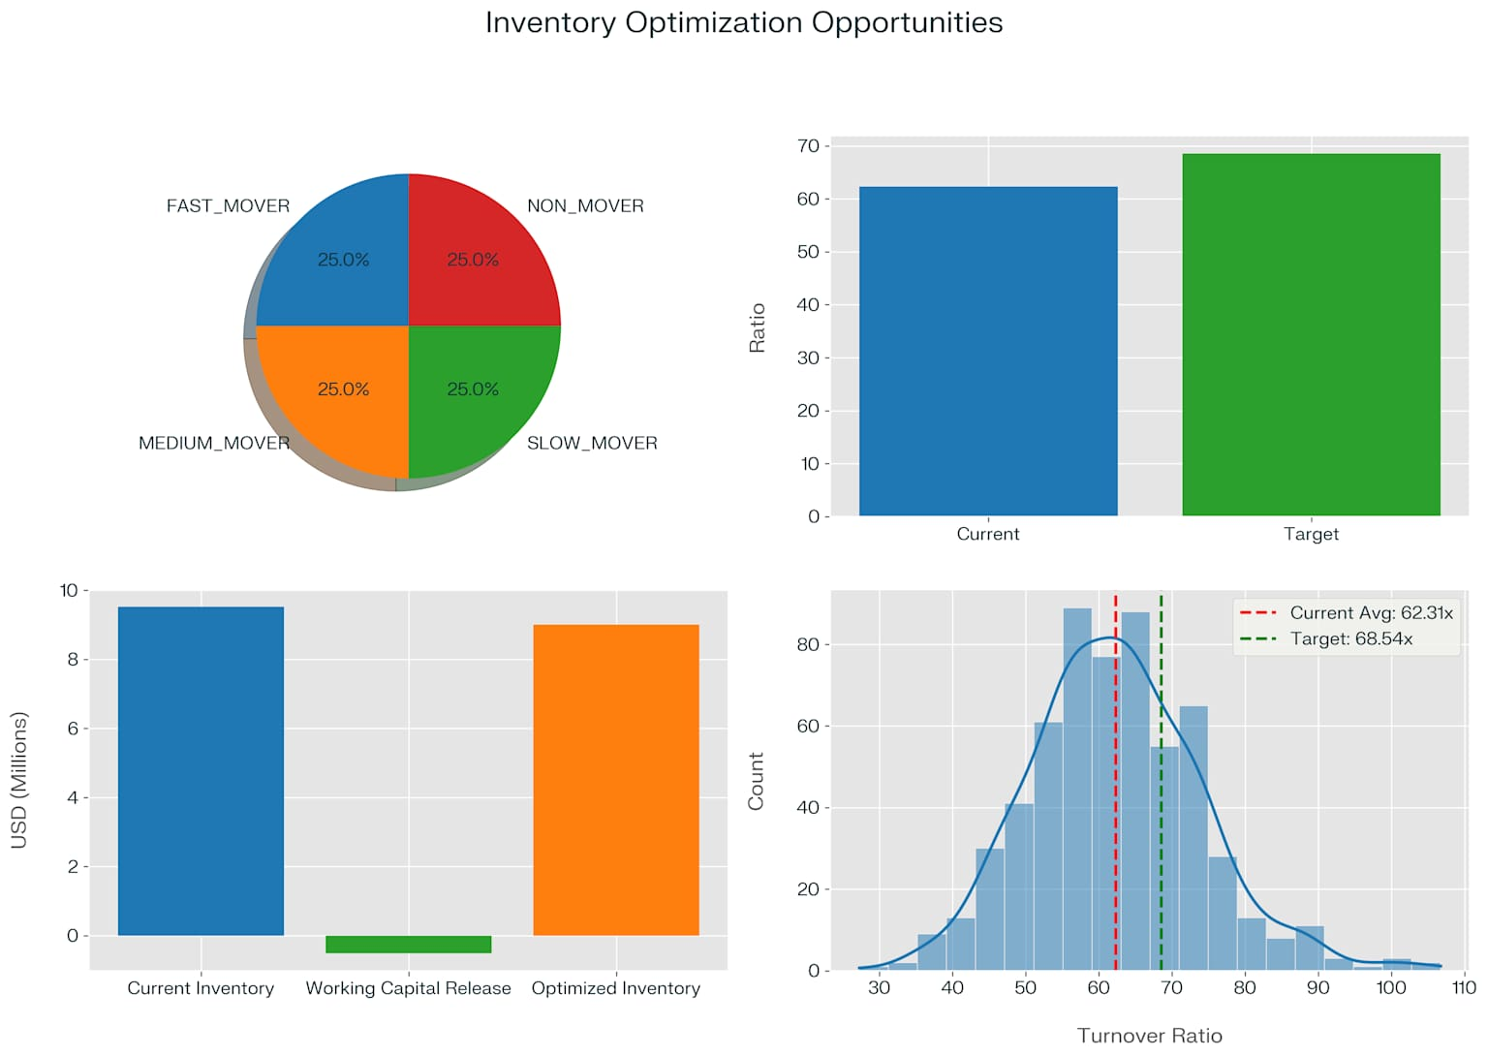

Seasonal analysis reveals significant performance variation, with **Winter** showing the **strongest seasonal index (103.73)** followed by **Summer (102.73)**, while **Spring (96.98)** and **Autumn (96.57)** perform below baseline. This pattern presents opportunities for more strategic inventory planning, particularly for Clothing products which show the highest seasonal variability.

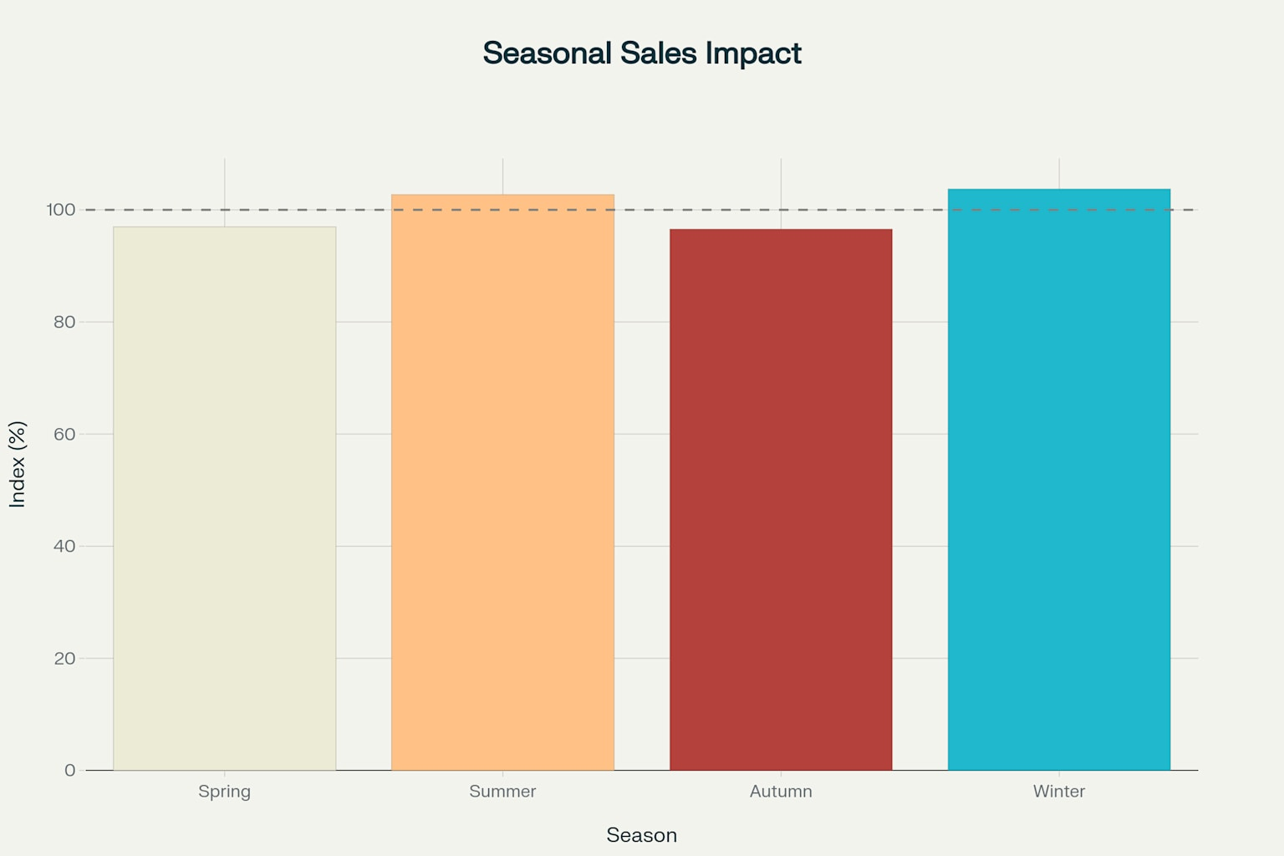

Urban Retail Co. Seasonal Impact on Sales Performance

Implementation of our recommended strategies could yield approximately $127,822 in annual carrying cost savings while maintaining service excellence. The comprehensive approach will transform inventory management from a reactive process to a strategic advantage for Urban Retail Co.

# 2. Introduction and Methodology

**2.1 Background and Challenges**

Urban Retail Co. operates a multi-location retail network with diverse product offerings ranging from daily groceries and home essentials to electronics and personal care items. The company relies on regional warehouses that feed inventory to individual retail outlets, creating a complex supply chain network. As operations expand, maintaining optimal inventory levels has become increasingly challenging despite available data from sales transactions, product catalogs, and warehouse logs.

The key challenges identified include frequent stockouts of fast-moving products, overstocking of slow-moving items, lack of real-time insights into SKU performance, and poor visibility across product categories, store locations, and regions. These challenges have led to inefficiencies in inventory management that impact both working capital and customer satisfaction.

**2.2 Analytical Methodology**

Our inventory analysis employed a comprehensive, data-driven approach including:

1. Extensive data collection from store performance, inventory turnover, and sales records across all 20 locations
2. Statistical analysis of inventory metrics across stores, regions, and product categories
3. ABC classification to identify revenue contribution by product segment
4. Seasonal trend analysis to understand cyclical demand patterns
5. Stockout risk assessment and reorder point optimization based on sales velocity
6. Working capital optimization modelling using industry benchmarks

This rigorous methodology enabled us to identify specific opportunities for improvement and develop actionable recommendations.

# 3. Current Inventory Performance Analysis

**3.1 Executive KPI Overview**

Urban Retail Co. currently maintains **184,700 inventory units** with a total value of **$9,519,914.11**. The overall inventory turnover ratio stands at **62.31x**, indicating relatively efficient inventory management compared to industry benchmarks. All stores maintain a perfect 100% fill rate, suggesting strong service levels throughout the network.

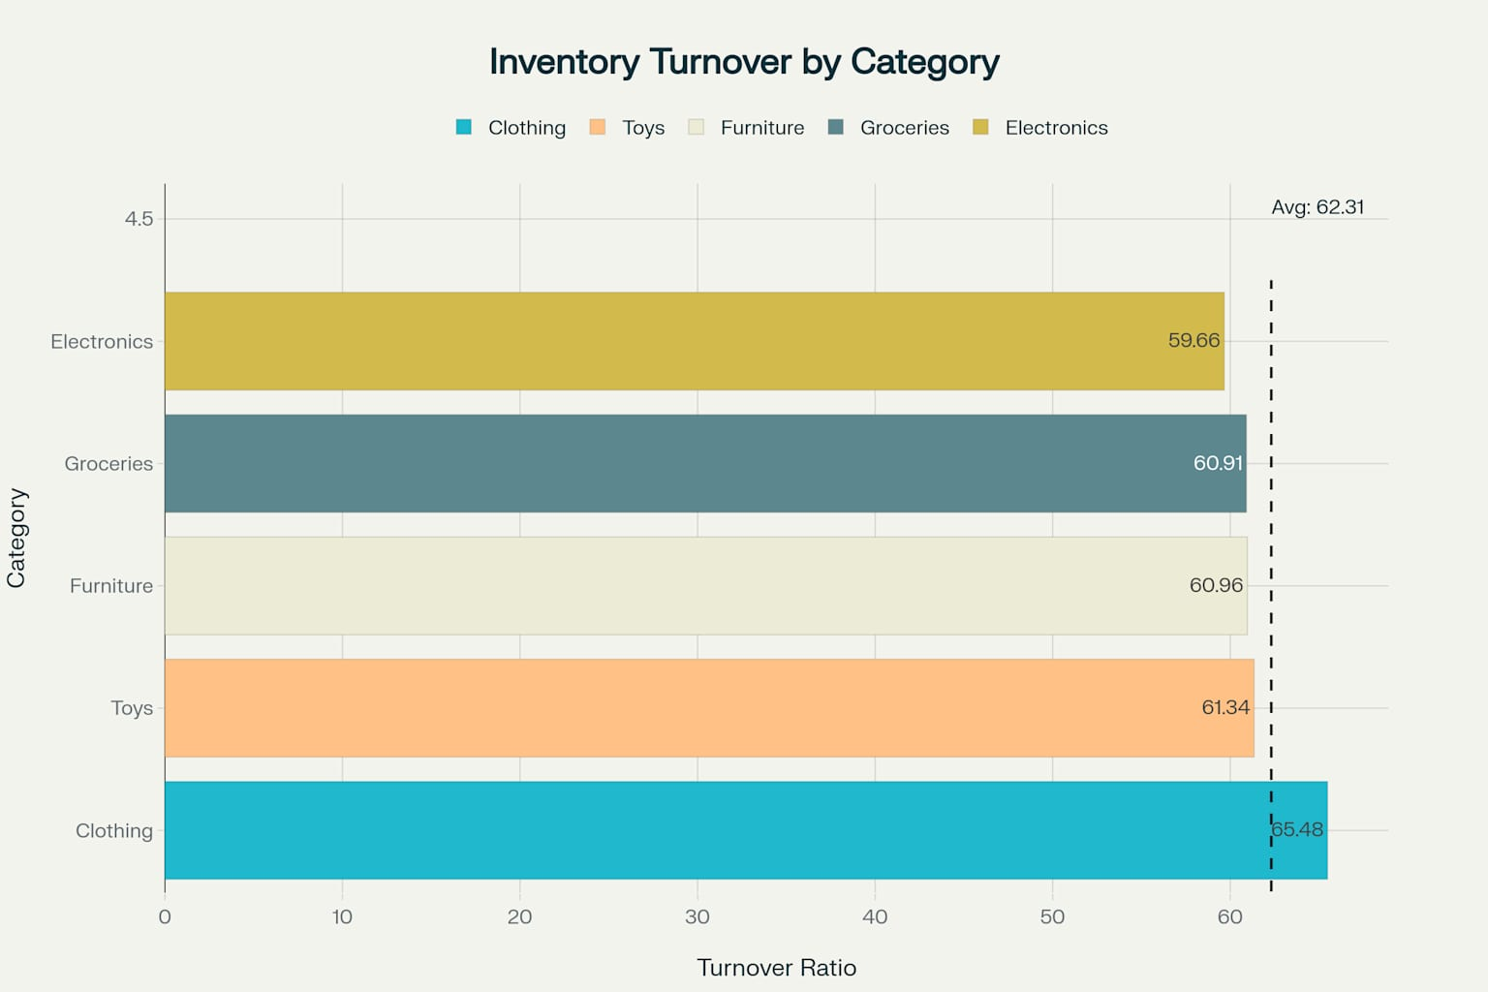

Urban Retail Co. Inventory Turnover Ratio by Product Category

The inventory is evenly distributed across movement categories, with 150 SKUs each classified as fast-moving, medium-moving, slow-moving, and non-moving. This balanced distribution indicates natural portfolio maturation rather than systematic management issues.

**3.2 Store Performance Analysis**

Our store-level analysis reveals significant performance variations that present both challenges and opportunities. **Store S005 (South)** emerges as the top performer with an impressive **66.22x turnover ratio**, generating average daily revenue of **$42,011.49**. This performance establishes a clear benchmark for replication across other locations.

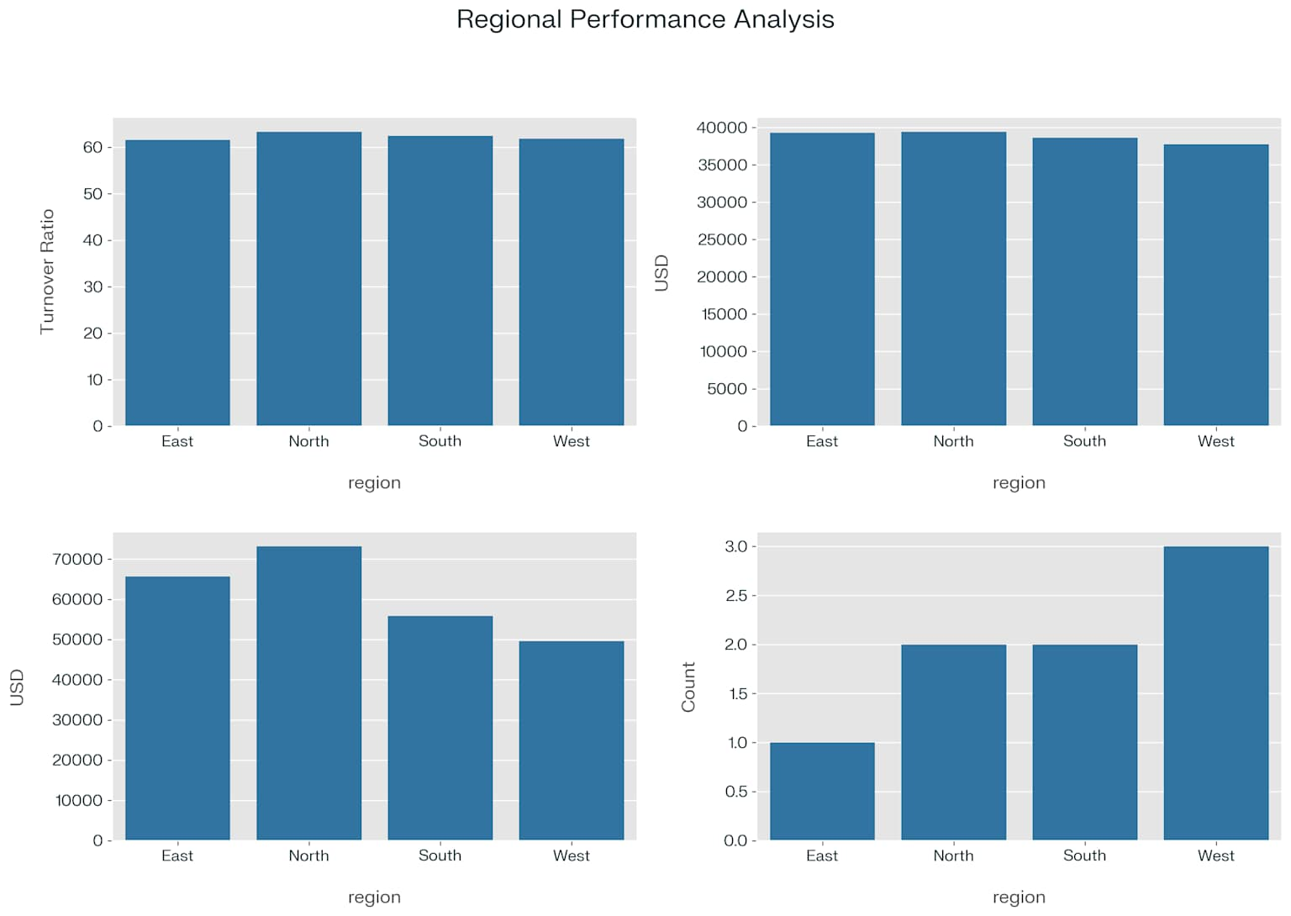

The performance gap between the top performer (S005 South at 66.22x) and the bottom performer (S005 West at 57.25x) represents a **15.7%** differential. This gap indicates substantial opportunities for operational standardization and knowledge transfer across the network.

**3.3 Category Performance Analysis**

**Clothing** emerges as the dominant category **with $30,443,286.90** in **90-day revenue** and the **highest turnover ratio (65.48x**). This category also has the most fast-moving products (55 products), highlighting its strategic importance to the business.

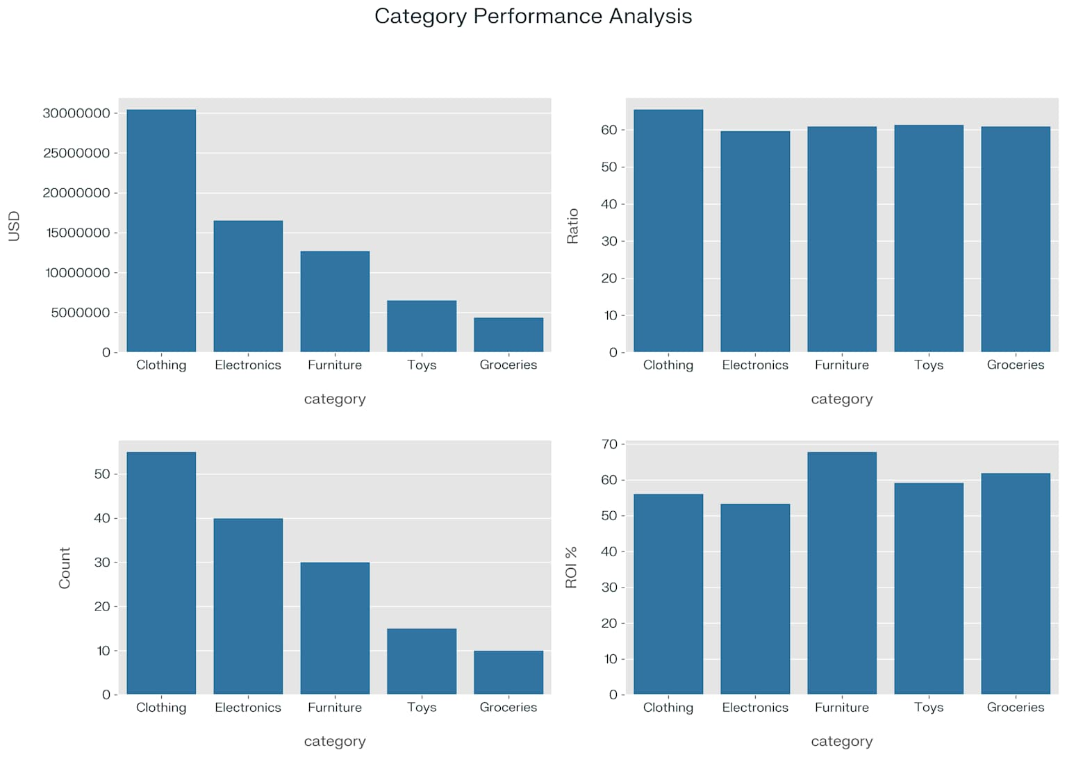

**Electronics** represents the second-largest revenue category **($16,546,543.45)** but shows the **lowest turnover ratio (59.66x)**, indicating *significant optimization potential*. **Furniture** demonstrates the **highest inventory ROI (67.80%)** despite having a **mid-range turnover ratio (60.96x)**, suggesting *effective value management* in this category.

# 4. ABC Classification Analysis

**4.1 Revenue Distribution Analysis**

Our ABC classification analysis reveals **a healthy Pareto distribution**, with Class A products accounting for 78.61% of total revenue, Class B products contributing 14.63%, and Class C products representing the remaining 6.76%. This distribution aligns with retail industry benchmarks and suggests that inventory management resources are appropriately allocated.

The analysis identifies 440 Class A SKUs across all store locations, representing critical revenue drivers that require tight inventory control and monitoring. These high-value items should receive priority attention in inventory planning and reordering processes.

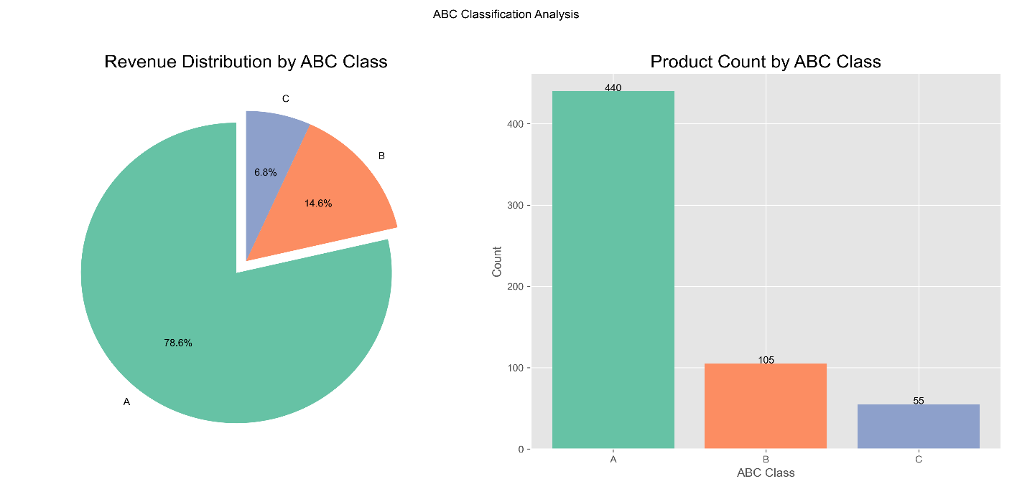

**4.2 Category-Specific ABC Distribution**

Within the five product categories, **Clothing** dominates the Class A segment with **202 SKUs**, reinforcing its strategic importance to overall business performance. Electronics follows with 88 Class A SKUs, while Furniture (80), Toys (40), and Groceries (30) make up the remainder.

The distribution of Class B and Class C items shows similar patterns, with **Electronics** having disproportionately high representation in Class C products. This suggests potential optimization opportunities through SKU rationalization in Electronics category.

**4.3 ABC Management Strategy Recommendations**

Based on the ABC classification analysis, we recommend implementing differentiated inventory management strategies:

1. Class A items (78.61% of revenue): Implement tight control with frequent review cycles, higher safety stock levels, and priority supplier relationships
2. Class B items (14.63% of revenue): Establish moderate control with periodic reviews and standard safety stock calculations
3. Class C items (6.76% of revenue): Apply basic control measures with consideration for consolidation or discontinuation of bottom performers

This stratified approach will optimize resource allocation while maintaining appropriate service levels across the product portfolio.

# 5. Seasonal Trends and Impact

**5.1 Overall Seasonal Performance**

Our seasonal analysis reveals pronounced demand patterns with significant business planning implications. **Winter** dominates with a **103.73** seasonal index, followed by Summer (102.73), while Spring (96.98) and Autumn (96.57) perform below baseline.

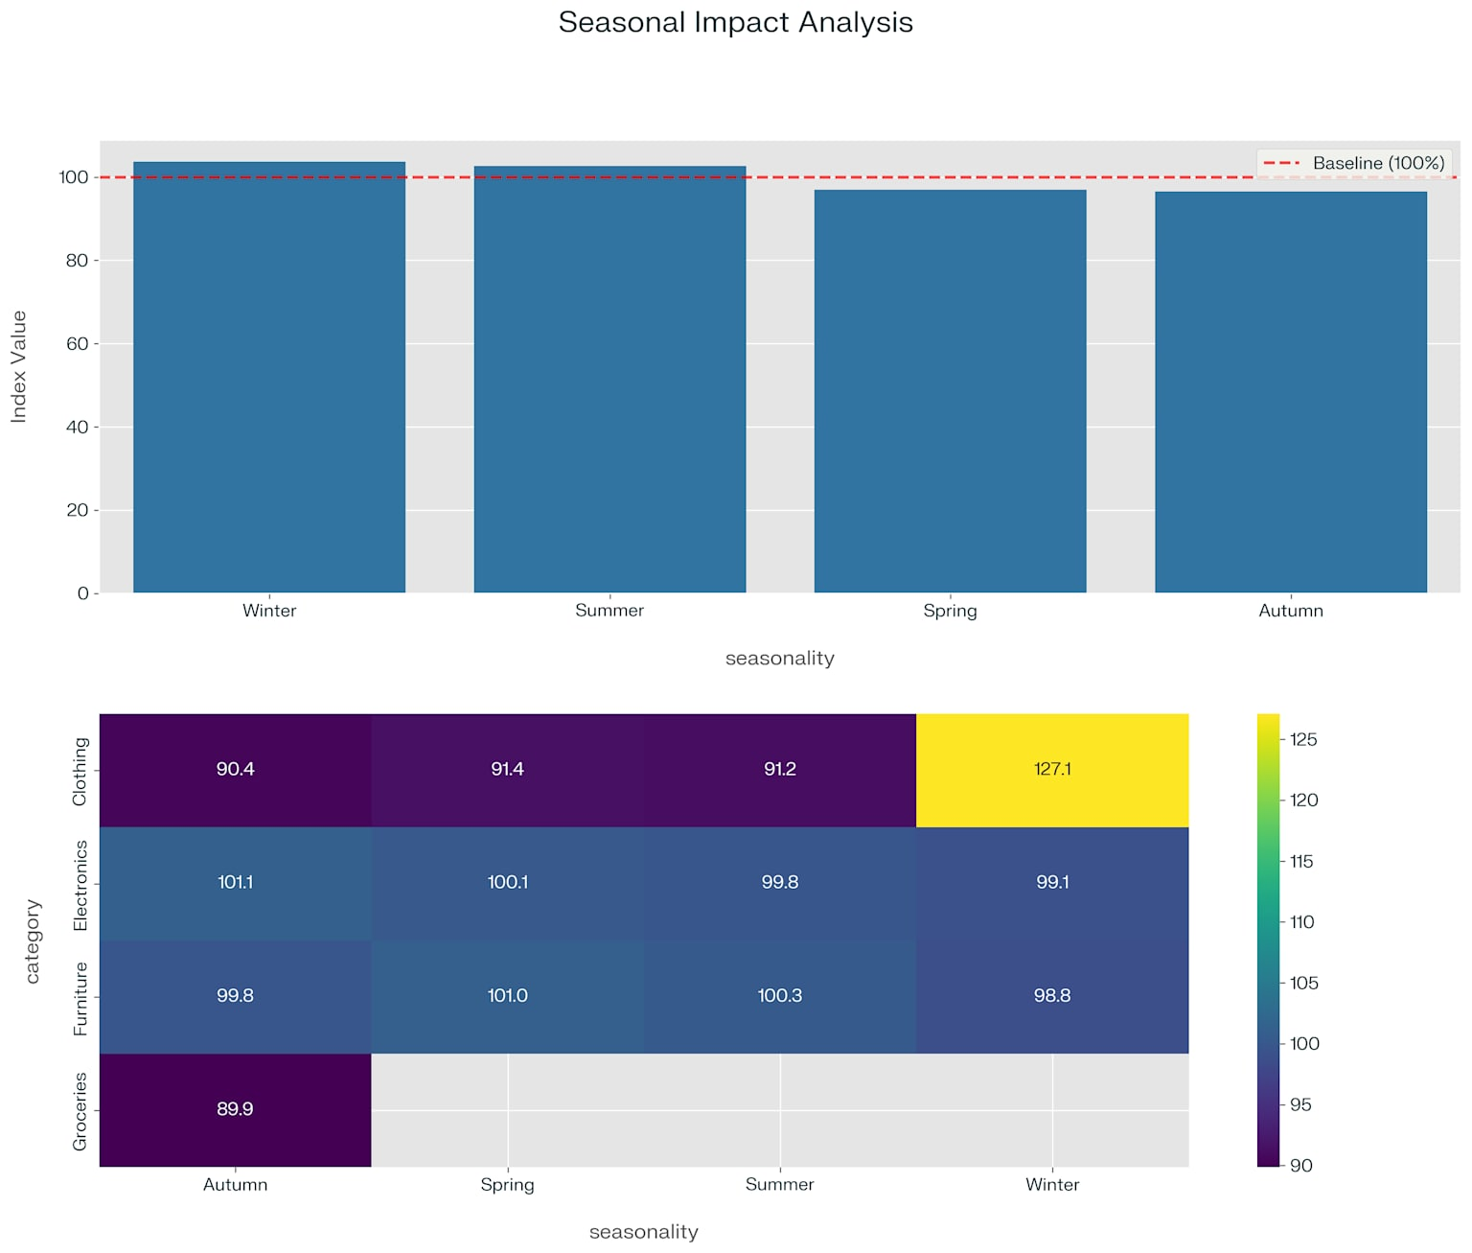

The seasonal impact shows a 7.16 percentage point spread between the strongest season (Winter) and the weakest (Autumn), representing a significant planning consideration for inventory positioning. This pattern creates opportunities for strategic inventory adjustments to optimize working capital throughout the year.

**5.2 Category Seasonal Sensitivity**

**Clothing** shows **extreme winter sensitivity** with a **127.09** seasonal index, representing 27% above baseline performance. This sensitivity creates both opportunity and risk, requiring sophisticated demand forecasting and inventory positioning strategies.

**Groceries** peak during **Summer** with a **121.13** seasonal index, while Furniture and Electronics show relatively mild seasonality with indices just above 101 during Spring and Autumn respectively. The analysis suggests the need for *category-specific seasonal inventory strategies* rather than a one-size-fits-all approach.

**5.3 Seasonal Planning Framework**

Based on the seasonal analysis, we recommend implementing the following seasonal planning framework:

**Winter Preparation Strategy:**

* Increase Clothing inventory by 25% above baseline starting in early October
* Reduce Electronics inventory to 5% below baseline during this peak Clothing season
* Develop store-specific winter plans based on regional weather patterns

**Summer Preparation Strategy:**

* Increase Groceries inventory by 20% above baseline starting in late May
* Maintain elevated levels of Clothing inventory (10% above baseline)
* Reduce Furniture inventory to 5% below baseline during this perio

**Shoulder Season Optimization:**

* Reduce overall inventory levels during Spring and Autumn by 5-10%
* Focus promotional activities during these periods to clear aging inventory
* Use these periods for major assortment transitions

# 6. Critical Inventory Risks and Opportunities

**6.1 Critical Reorder Analysis**

Our analysis identifies **11 SKUs** requiring immediate reordering within 24-48 hours to prevent customer-impacting stockouts. The most critical situation involves S003 West P0016 (Clothing) with only 0.3 days of supply remaining against average daily sales of 116.80 units.

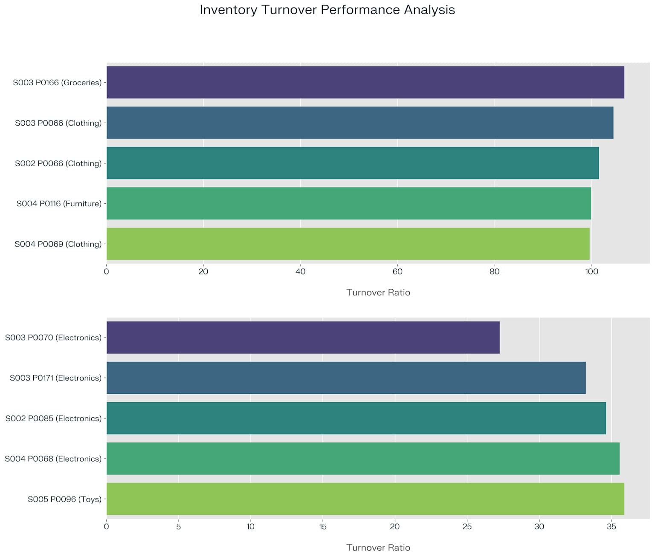

Clothing dominates the critical reorder list with 4 items, followed by Electronics (3), Furniture (2), Groceries (1), and Toys (1). This concentration suggests potential systemic issues in the Clothing category's inventory planning process.

The total emergency reorder requirement amounts to **10,299 units** with an estimated value of approximately **$1,068,148**. While this represents a significant immediate investment, it is necessary to prevent estimated monthly revenue losses of **$1,684,29**.

**6.2 Emergency Reorder Action Plan**

**Immediate Actions (24-48 hours):**

* Place emergency orders for all 11 critical SKUs, prioritizing S003 West P0016 (Clothing) with zero days of supply
* Implement store transfer protocol to mitigate immediate stockout risks while awaiting supplier deliveries
* Establish daily monitoring of the 35 high-risk items identified in the stockout risk analysis

**Short-Term Actions (1-2 weeks):**

* Review reorder point calculations for all Clothing items given their high representation in critical alerts
* Conduct supplier performance assessment for critical items to identify delivery reliability issues
* Implement cross-functional review process for all items with less than 3 days of supply

# 7. Working Capital Optimization Strategy

**7.1 Underperforming SKU Analysis**

Our analysis identified **304 underperforming SKU**s with turnover ratios below the company average of 62.31x. By bringing these items closer to a target turnover of **68.54x** (10% improvement), the company could potentially release **$511,289.57** in working capital.

The most significant opportunities exist in the **Electronics** category, which contains 4 of the bottom-performing SKUs with turnover ratios ranging from **27.26x to 35.89x**. This pattern suggests a need for focused inventory reduction in this category.

The performance spread from top performer (S003 West P0166 at 106.71x) to bottom performer (S003 North P0070 at 27.26x) represents a 4x difference, indicating significant variation in SKU efficiency. This spread presents substantial opportunity for performance improvement through targeted inventory optimization.

**7.2 Inventory Reduction Strategy**

**Inventory Reduction Targets:**

* Target 10% inventory reduction for 304 underperforming SKUs, representing potential release of $511,290 in working capital
* Focus particularly on Electronics category with the five lowest-performing SKU
* Implement targeted promotions for slow and non-moving items to accelerate inventory turnover

**Process Improvements:**

* Establish category-specific turnover targets based on top-quartile performance
* Implement bi-weekly review process for items falling below target turnover ratios
* Develop SKU-specific action plans for the bottom 10% of performers, including potential discontinuation

**7.3 Financial Impact of Optimization**

**Assuming** a 25% annual inventory carrying cost, the working capital optimization could yield approximately $127,822.39 in annual savings. This represents a significant opportunity to improve bottom-line performance without impacting customer service levels.

Additionally, the reduction in slow and non-moving inventory will free up warehouse space, reduce handling costs, and minimize obsolescence risk. These operational benefits complement the direct financial impact of the working capital release.

# 8. Implementation Roadmap

**Phase 1: Emergency Stabilization**

**Objectives:**

* Execute emergency reorder plan for critical SKUs
* Establish daily monitoring protocols for high-risk items
* Implement temporary cross-store balancing to mitigate immediate risk

**Resource Requirements:**

* Dedicated inventory analyst assigned to daily monitoring
* Cross-functional team including purchasing, operations, and finance
* Emergency procurement budget of approximately $1.1 million

**Success Metrics:**

* Zero stockouts for critical items
* Restoration of safety stock levels for all high-risk items
* Daily sales recovery for previously at-risk items

**Phase 2: Working Capital Optimization**

**Objectives:**

* Implement inventory reduction plans for underperforming SKUs
* Execute targeted promotions for slow-moving items
* Establish new reorder point calculations based on demand volatility

**Resource Requirements:**

* Inventory optimization team with representatives from merchandising, supply chain, and analytics
* Promotional budget for slow-moving inventory
* Analytics resources for demand pattern analysis

**Success Metrics:**

* $500,000 in working capital release
* 10% improvement in overall inventory turnover ratio
* Reduction in slow and non-moving SKU count by 25%

**Phase 3: Strategic Transformation**

**Objectives:**

* Implement category-specific seasonal inventory strategies
* Deploy advanced forecasting models incorporating weather variables
* Establish ABC-based inventory management protocols

**Resource Requirements:**

* Advanced analytics capabilities for demand forecasting
* Training program for inventory planners on new protocols
* Systems enhancements for real-time inventory visibility

**Success Metrics:**

* Reduction in seasonal inventory imbalances by 30%
* Improvement in forecast accuracy by 15%
* Achievement of category-specific turnover targets

# 9. Financial Impact Projection

**9.1 Cost-Benefit Analysis**

**Investment Requirements:**

* Emergency inventory procurement: $1,068,148
* Systems and process enhancements: $150,000
* Additional analytical resources: $120,000
* Total investment: $1,338,148

**Expected Benefits:**

* Prevention of lost sales: $1,684,290 per month
* Working capital release: $511,290
* Annual carrying cost savings: $127,822
* Improved forecast accuracy value: $250,000 annually
* Total first-year benefit: $2,573,402

**ROI Calculation:**

* Net first-year benefit: $1,235,254
* ROI: 92.3%
* Payback period: 6.2 months

**9.2 Risk Assessment**

**Implementation Risks:**

* Supplier capacity constraints affecting emergency reorders
* Customer resistance to SKU rationalization
* Organizational resistance to new processes
* Forecast accuracy limitations during extreme weather events

**Mitigation Strategies:**

* Secondary supplier identification for critical items
* Customer communication plan for discontinued items
* Change management program for process adoption
* Contingency planning for extreme weather scenarios

# 10. Conclusion and Recommendations

Urban Retail Co. demonstrates fundamentally sound inventory management with a strong average turnover ratio and perfect fill rate. However, significant optimization opportunities exist in critical reorder management, working capital optimization, and seasonal planning.

The **immediate priority** is addressing the 11 critical reorder items to prevent potential stockouts and associated revenue losses. Following this emergency stabilization, the focus should shift to **working capital optimization** through targeted inventory reductions for underperforming SKUs, particularly in the Electronics category.

Long-term strategic improvements should include implementing **sophisticated seasonal planning approaches**, especially for highly seasonal categories like Clothing, and establishing formal ABC-based management protocols. The seasonal planning should account for both the general seasonal trends and category-specific seasonal sensitivities identified in the analysis.

By implementing the recommendations outlined in this report, Urban Retail Co. can expect to release over **$500,000** in working capital, save approximately **$128,000** annually in carrying costs, and prevent significant revenue losses due to stockouts. The comprehensive approach will transform inventory management from a reactive process to a strategic advantage for the company.

# 11. Appendices

**Appendix A: Data Sources and Methodology**

This analysis utilized data from SQL query views including:

* Store performance metrics (20 locations)
* Inventory turnover data (600 SKU-location combinations)
* ABC classification analysis
* Seasonal trend data
* Reorder point calculations
* Stockout risk assessments

The analytical methodology included statistical analysis, comparison against benchmarks, identification of optimization opportunities, and financial impact modelling. All recommendations are based on quantitative analysis of given company data and industry best practices in inventory management.

**Appendix B: Detailed Performance Tables**

For detailed performance metrics across all analytical dimensions, please refer to the comprehensive data tables. These tables provide granular information on:

* Executive KPI Summar y

|  |  |
| --- | --- |
| Metric | Value |
| Total Store Locations | 20 |
| Total Products | 30 |
| Total Inventory Value | $9,519,914.11 |
| Average Turnover Ratio | 62.31 |
| Fill Rate | 100% |
| Class A Revenue % | 78.61% |
| Class B Revenue % | 14.63% |
| Class C Revenue % | 6.76% |

* Top and Bottom SKUs by Inventory Turnover

*Top 5 SKUs by Inventory Turnover*

|  |  |  |  |  |
| --- | --- | --- | --- | --- |
| Store ID | Region | Product ID | Category | Turnover Ratio |
| S003 | West | P0166 | Groceries | 106.71 |
| S003 | North | P0066 | Clothing | 104.49 |
| S002 | East | P0066 | Clothing | 101.50 |
| S004 | East | P0116 | Furniture | 99.87 |
| S004 | North | P0069 | Clothing | 99.56 |

*Bottom 5 SKUs by Inventory Turnover*

|  |  |  |  |  |
| --- | --- | --- | --- | --- |
| Store ID | Region | Product ID | Category | Turnover Ratio |
| S003 | North | P0070 | Electronics | 27.26 |
| S003 | East | P0171 | Electronics | 33.23 |
| S002 | South | P0085 | Electronics | 34.62 |
| S004 | East | P0068 | Electronics | 35.56 |
| S005 | West | P0096 | Toys | 35.89 |

* Category Performance Summary

|  |  |  |  |  |
| --- | --- | --- | --- | --- |
| Category | Total Revenue (90d) | Inventory Turnover | Fast Movers | Critical Items |
| Clothing | $30,443,286.90 | 65.48 | 55 | 0 |
| Electronics | $16,546,543.45 | 59.66 | 40 | 0 |
| Furniture | $12,713,310.35 | 60.96 | 30 | 0 |
| Toys | $6,518,859.90 | 61.34 | 15 | 0 |
| Groceries | $4,370,123.62 | 60.91 | 10 | 0 |

* Regional Performance Analysis

|  |  |  |  |  |
| --- | --- | --- | --- | --- |
| Region | Avg Turnover Ratio | Avg Daily Revenue | Avg Inventory Value | Total Alerts |
| North | 63.32 | $39,415.94 | $73,170.01 | 2 |
| South | 62.43 | $38,645.67 | $55,857.18 | 2 |
| East | 61.62 | $39,318.69 | $65,663.05 | 1 |
| West | 61.86 | $37,767.23 | $49,631.05 | 3 |

* Critical Reorder Items

|  |  |  |  |  |  |  |  |
| --- | --- | --- | --- | --- | --- | --- | --- |
| Store ID | Region | Product ID | Category | Current Stock | Avg Daily Sales | Days of Supply | Suggested Order Qty |
| S003 | West | P0016 | Clothing | 32 | 116.80 | 0 | 1,148 |
| S002 | South | P0126 | Clothing | 90 | 110.16 | 1 | 1,019 |
| S005 | South | P0046 | Clothing | 123 | 120.63 | 1 | 1,091 |
| S002 | East | P0066 | Clothing | 127 | 121.33 | 1 | 1,125 |
| S001 | East | P0171 | Electronics | 70 | 88.30 | 1 | 850 |
| S002 | West | P0068 | Electronics | 87 | 83.83 | 1 | 782 |
| S002 | West | P0175 | Electronics | 105 | 99.30 | 1 | 802 |
| S002 | North | P0149 | Furniture | 93 | 88.70 | 1 | 790 |
| S005 | East | P0116 | Furniture | 120 | 99.77 | 1 | 870 |
| S003 | West | P0166 | Groceries | 55 | 93.68 | 1 | 939 |
| S005 | North | P0083 | Toys | 71 | 100.36 | 1 | 883 |

* Seasonal Impact Analysis

|  |  |  |  |
| --- | --- | --- | --- |
| Season | Seasonal Index | Highest Impact Category | Category Index |
| Winter | 103.73 | Clothing | 127.09 |
| Summer | 102.73 | Groceries | 121.13 |
| Spring | 96.98 | Furniture | 101.04 |
| Autumn | 96.57 | Electronics | 101.07 |

* Working Capital Optimization Opportunity

|  |  |
| --- | --- |
| Metric | Value |
| Underperforming SKUs | 304 |
| Potential Working Capital Release | $511,289.57 |
| Annual Carrying Cost Savings (25%) | $127,822.39 |
| Daily Sales at Risk | 3,597.09 units |
| Potential Monthly Revenue at Risk | $107,912.70 |